DIRECTIONS:
4316 Abrams Road, Dallas, TX
For Google Map click here

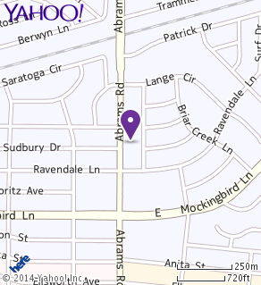

NEARBY PLACES TO STAY:

Holiday Inn Dallas Central - Park Cities
6070 North Central Expressway, Dallas, TX 75206 (Formerly Radisson Hotel Central Dallas)

La Quinta Inn Dallas Uptown
4440 N. Central Expressway, Dallas, TX 75206-6525 (East Dallas)

La Quinta Inn & Suites Dallas North Central
10001 North Central Expressway, Highway 75, Dallas, TX 75231-4103

Other questions?

Contact Sandy Jones, Professional Development Director, NAPO-DFW
214-354-3008 or via email profdevelopment@napodfw.com

